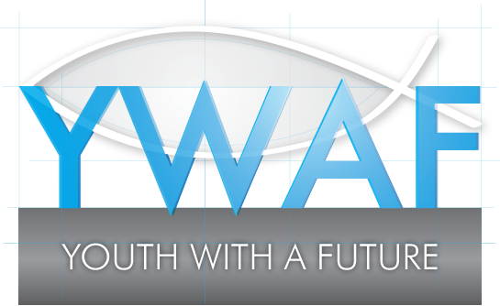 Thank you for your support. It really does make a difference!

STANDING ORDER FORM
If you would like to make a regular donation to YWAF, please print this form and either post or email it to us. You can either complete it on-screen, print it out and sign it, or print out the blank form and then complete it, whichever you prefer.
Forename
Surname
Address
Postcode
Email
INSTRUCTION TO YOUR BANK/BUILDING SOCIETY
To the Manager
Bank/Building Society Name
Address
Postcode
Sort Code
Name(s) of account holder(s)
Your account number
Please pay YWAF the sum of £ per month quarter year (please select as appropriate) until further notice.
Starting on (dd/mm/yy)
Your Signature | _______________________________ Date ______________
YWAF’s bank details
Address: The Co-operative Bank, PO Box 250, Delf House, Southway, Skelmersdale, WN8 6WT.
Account Name: Youth with a Future (YWAF)
Account No: 6 5 0 9 1 3 0 0 (six-five-zero-nine-one-three-zero-zero)
Sort Code: 08-92-99 (zero eight – ninety two – ninety nine)
If you are a UK tax payer, we can claim tax relief on all your gifts, large or small. This means that if you are currently a basic rate tax payer, YWAF can reclaim 25p for every pound you give. To make your donation – and our work – go even further, please complete the giftaid declaration below.
giftaidit

□ I want to Gift Aid my donations to YWAF. I am a UK tax payer and understand that if I pay less Income Tax and/or Capital Gains Tax than the amount of Gif Aid claimed on all my donations in a tax year (6 April to 5 April) it is my responsibility to pay any difference.
□ I do not pay tax and this statement does not apply to me.
□ I would prefer not to make a giftaid declaration.

